Wiki

ICP 6

Team: 1

Members: Ahmad, Cameron, Marajan, Syed Jawad

Objective:

The objective of this lab is to get familiar with Java Script and its applications in Node Red. Initially, the class started with downloading a source code for lower text and modify the source code to change Fahrenheit to Celsius. This task was accomplished by modifying Java Script provided in the package.Jason file in way that it was taking the input Fahrenheit value and change it to a Celsius value by using a formula provided in the JS code. The screen shot of this task is below:

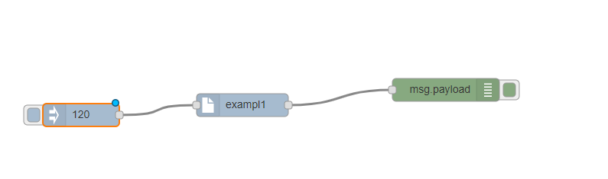

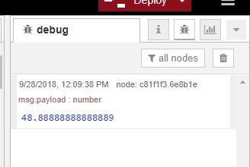

The other task was to develop a traffic signal using node red flows. This task was also accomplished in the class. This task is filmed, and video of this task is given below:

Finally this traffic signal flow